Navrachana University celebrates national startup day, 7 years of startup India

On this National Startup day where the whole nation is celebrating 7 years of startup ecosystem in india, Navrachana University hosted an ideation workshop delivered by Mr. Rajat Singhania. 155 Students from pure sciences, Business, law and engineering graduates were present with their startup ideas and they discussed about how to convert their ideas into potential startups.

The session talked about about How to ideate, what is a good idea, types of ideas, basics of ideation, stages of ideation and how to ideate better. 7 ideas were pitched and Mr. Rajat helped them to understand more on how to validate your idea and get first 100 customers. Also, being charter member of T
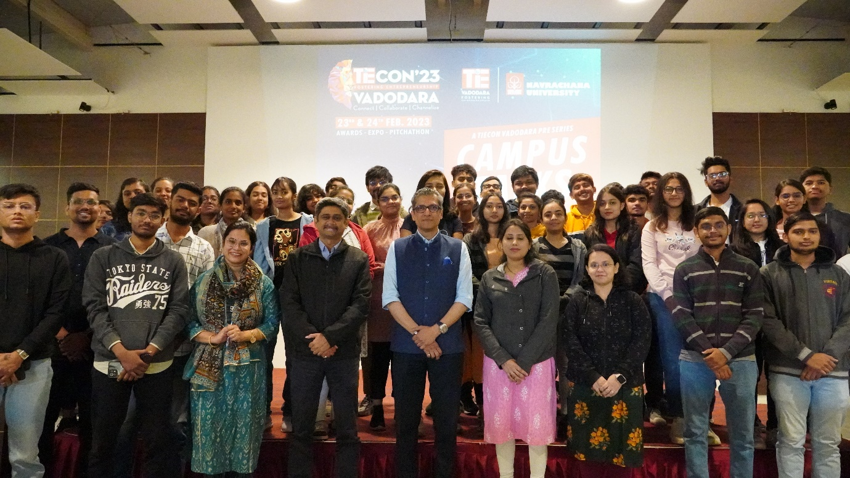

Also, As you might be aware that Navrachana University is been recognised by Government of India to setup an incubation centre to support innovators and startups. This venture is now registered as a section 8 company and it is called Navrachana Innovation Foundation. Under this organisation a variety of activities will be undertaken that will promote innovation, design, creative thinking, startup culture and promoting this culture not only in the university but in this entire city and in the state at large. We are all set to start our innovation studio and for this a new logo has to be designed. This is call for design of logo of Navrachana Innovation Foundation and the brief of the same is mentioned below: The design of this logo should represent the ethos and aspirations of this new organisation of Navrachana University. This organisation is committed towards the whole culture of startups by supporting innovation, entrepreneurship, creativity, design and logo in some sense should capture this spirit. The logo will be used in a variety of formats like website, letter-heads, social media posts etc. and participants should keep in mind the wide variety of ways in which this logo would be represented.

Designers across the state are invited to participate and Prize money of worth 10,000 INR have been declared and winners will be announced on 26th January 20023.

